# AGE ESTIMATION BY MULTI SCALE CNN

1. Introduction
2. Model
3. Testing (Define loss function)
4. Workflow
5. Conclusion (Advantage, limitation and action items)

1) Introduction:

- Target of this document shows a workflow for building an application by machine learning. We choose age estimation as our first application because there are many research result and good data base. Besides, it is used for many applications (demo-graphics analysis, user management, video security surveillance,..) and input for other neural networks.

- We refer “Age Estimation by Multi-scale Convolutional Network” paper with good testing result to design a workflow. It contains preprocess, construct a CNN network, define test criteria.

2) Model:

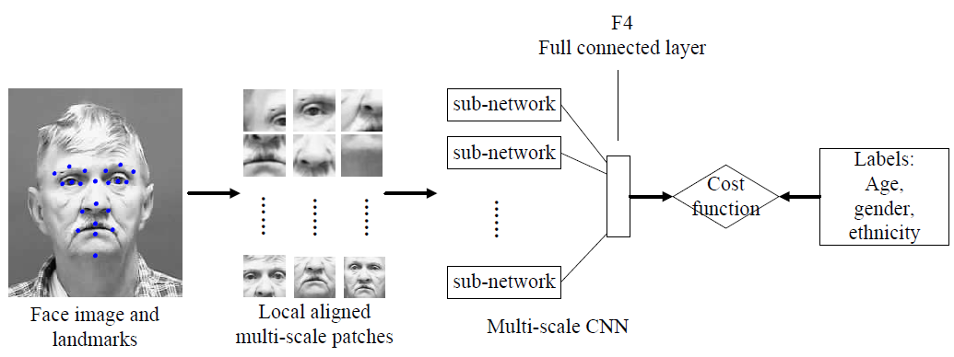

Fig. 1. The structure of the proposed network. The input face image is cropped into many local aligned patches. All patches are fed to the multi-scale convolutional network. The response of each patch are combined at the full connected layer to estimate the age, gender and ethnicity.

We use ASM (Activate Shape Model) to detect facial land mark and crop the input image into many local aligned patches.

2-1) Preproces phase (crop input image into patches with multi scale)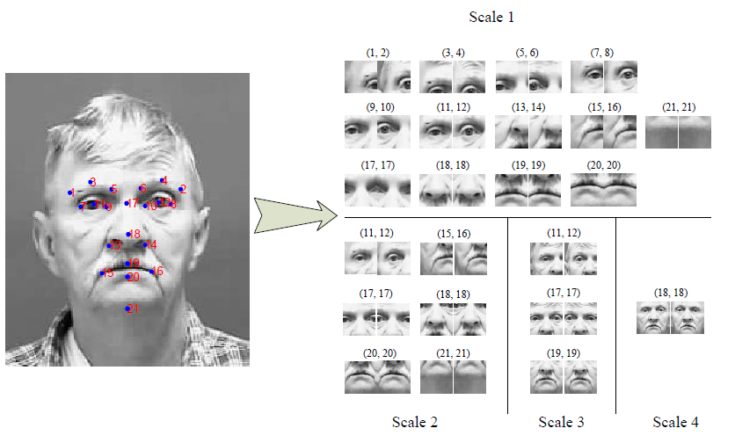

Fig. 2. 23x2 multi-scale patches cropped from a face image based on its corresponding  
landmarks. The resolution of all patches are 48 x 48. The patches from the right half  
of face are mirrored to augment the database.

2-2) CNN for Age Estimation

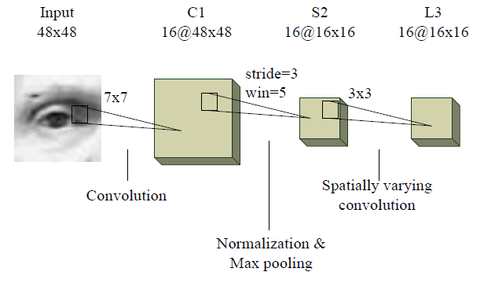

Fig. 3. The structure of sub-network for each patch. The input of sub-network are face patches and the output are sent to the F4 layer in Fig. 1.

3) Workflow

- Use ASM to detect facial land mark.

=> 1 question is that in testing phase, do we must use it?

- Crop input image into patches with key point alignment and multi scale

- Create CNN network

- Prepare data base

- Training model

- Define test criteria and perform testing

- Compare result with reference model and get conclusion

- Point out advantage, disadvantage and action items.